**Case study of UX/UI design work at Sopra Steria while working for UK Department Of Education**

**Case study** involved an up-close, in-depth detailed examination of the subject in question. Case studies involved both qualitative and quantitative analysis and research methods.

**Formal qualitative analysis and research** methods involved:

* Usability Testing
* A/B Testing
* Surveys & Questionnaires
* Focus Groups
* Card sorting
* User personas

**Formal quantitative analysis and research** methods were to receive a fortnightly google analytics report on various screens, their performances and any problems identified.

**Initiated** with a brief introduction of the problem posed and if the problem could be solved through a case study with a view to design a new User Experience UX and new set of screens.

**Problem posed was how we could reduce or eradicate Fraud** from the existing childcare grants paid by the UK government to student parents. Presently the grant for student parents called the Childcare Grant is paid directly to the student parent’s bank accounts. It was identified that there is a lot of Fraud to prevent from taking place in today’s world.

**High Level Design** introduced a new system/solution called Childcare Grant Payment system managed by a 3rd party partner of Department of Education.

This meant new set of screens allowing student parents who were awarded the grant to login to childcare grant payment system also known as CGPS to view their grant and the payment requests received from childcare providers.

The above also meant that the child care grant funds are not directly paid into student parents’ Bank Accounts but instead shall be held in their CGPS account.

At this stage, the student parents can either approve or dispute the payment request from childcare providers. This would mean that the childcare grant is directly paid to childcare providers thereby reducing fraud.

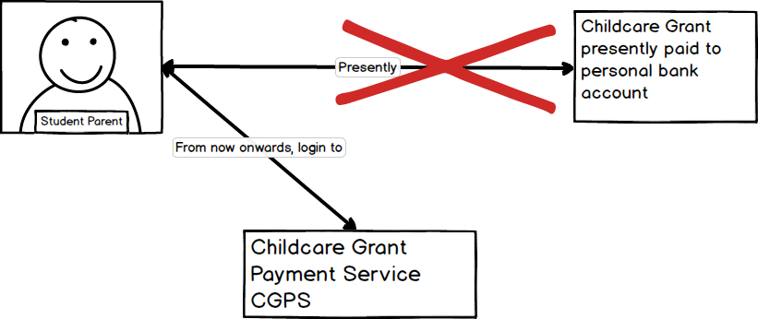

**Detailed User Experience also called UX Analysis and Design** was initiated with UX site map.



While designing individual screen layouts and information on screens, the principle of progressive disclosure and graceful degradation were followed to produce UX designs for A/B testing.

**A/B Testing & in-depth case study:**

Following the **principle of Progressive disclosure**, the below UX designs were produced for **A/B testing**.

**Option A** was to display the childcare grant remaining from which the end users can pay the childcare providers from. The student parents shall be presented with 3 options of paying the amount in full OR paying a partial amount OR disputing the payment request

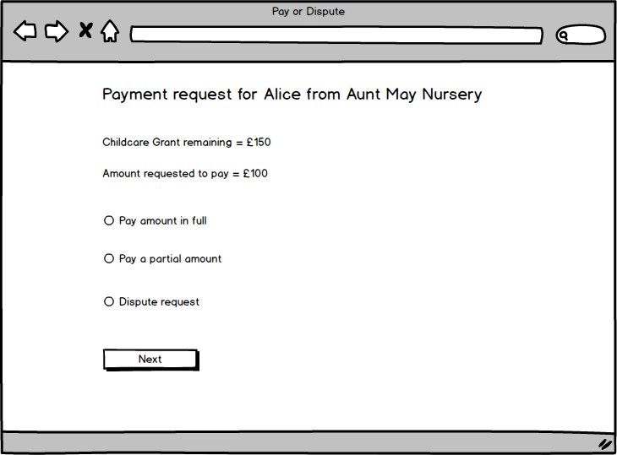

**Option B** displaying the remaining childcare grant remaining from which the end users can pay the childcare providers from. The student parents shall be presented with only 2 options of approve payment request OR dispute payment request.

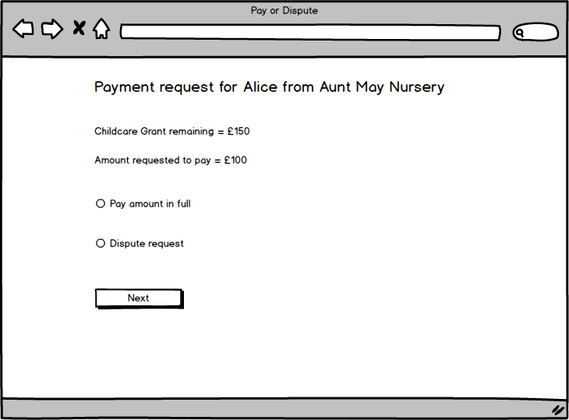

**Design Review with the UX Research/Design Team, Products & Policy**

The second set of designs followed the **principle of graceful degradation**. The screen had all the details in one place but could mean an information overload and hence was skimmed down to the above options A and B for A/B testing. The screen which was originally felt to be an information overload presented the end users with Childcare Grant remaining, the payment requested for, amount to pay, split up of the full bill itself with an icon that can be expanded and collapsed, and the 3 options to either pay the full amount OR pay partial amount OR dispute the payment request.

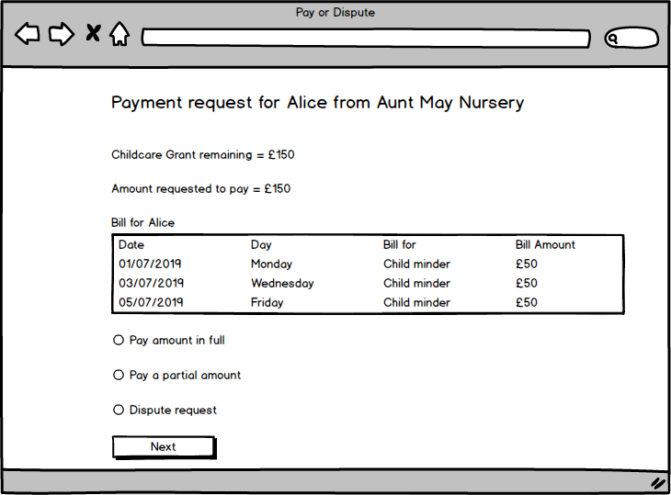

**Conclusions from A/B testing were such that:**

* Too much information on screen confused the end users.
* End user quotes were that I would be very happy if the screen gave me all the information to do as little as possible. In other words, the screen works out everything for me to review and approve.